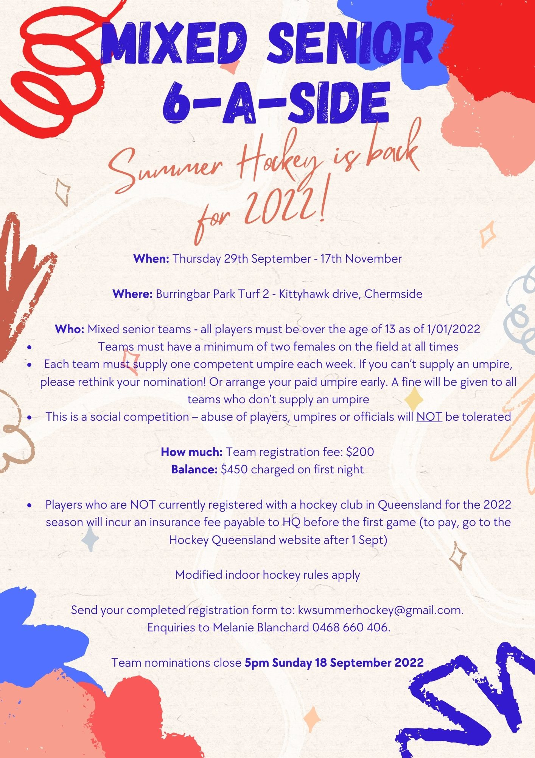
6-a-Side 2022
Senior Team Registration

Team Name:_____________________________________________________________
Shirt Colour: 1st preference_______________________ Second preference: ____________________
Player’s name | DOB | Phone | Club registered 2022 | Grade played 2022

Team manager: ______________________________________
Phone: _________________________

Email: ______________________________________________
Note: email must be supplied as any changes to draw will be communicated via email
Please note:
- A non-refundable $200 registration fee per team is to be paid in advance with this registration form (preferably by credit card and fees will be processed on or around the first round)
- The balance ($450) of games fees is payable before the first game on the first night of play
- Players who are NOT currently registered with a hockey club will incur a small insurance fee payable to HQ before the first game
- Registered club players in 2022 are covered by insurance with Hockey Qld to 31 December 2022.
Payment Details
☐Cash ☐ Payment at Canteen on the first night ☐ Direct Debit
Account Details:
Kedron Wavell Hockey Club
BSB: 064000
A/C: 14907132
Insurance
Information for insurance for players not registered with a hockey club in 2022 - after 1 September, go to Hockey Queensland’s web page to find the online registration process (under the ‘Playing’ tab, ‘Summer Hockey Registration’)

FRIDAY NIGHT 6 –A-SIDE RULES
- This is a social competition, there is no points or trophies
- Abuse of players (your own or opposition), umpires or organisers will not be tolerated
- Normal rules of hockey apply except for:
- No hitting or slap hitting – pushing only
- No short corners – if there is a penalty in the circle, a free hit is awarded 5m outside the circle and normal rules apply (travelling 5m before entering circle, etc.)
- No long corners – it is a push by the defending team from inside the circle unless intentional – then it is a free hit 5m outside the circle
- 2 females on the field at all times

FRIDAY NIGHT 6-A-SIDE HOUSEKEEPING
1. Umpires to check in before each game at the tech bench
3. All players must have played Association Hockey in QLD in 2022 or have paid the HQ insurance.

